EXPERIMENT 5 Date:
- Create an Amazon EC2 instance and set up a web-server on the instance and associate an IP address with the instance. In the process, create a security group allowing access to port 80 on the instance.
OR
- Do the same with OpenStack

AIM
To create an Amazon EC2 instance, set up a web server on it, allow access on port 80, and access the website using an IP address.

What is EC2? (Very Basic)
Amazon Web Services EC2 (Elastic Compute Cloud) is a service that lets you rent a computer (called an instance) on the internet.
This computer:
  - Runs 24/7
  - Has an operating system (Linux / Windows)
  - Can host websites

What is a Web Server?
A web server is software that shows a web page when someone types an IP address in a browser. We will use:
  - Apache Web Server (httpd)

Requirements
  - AWS account
  - Internet
  - Laptop / PC

IMPORTANT POINTS

- Amazon Web Services (AWS) is a cloud computing platform that provides on-demand computing resources over the internet.
- EC2 (Elastic Compute Cloud) is an AWS service that provides virtual servers called
instances to run applications and websites.
- An EC2 instance is a virtual computer that runs in the AWS cloud with a selected operating system such as Linux or Windows.
- A web server is software that delivers web pages to users when they access a website through a browser.
- Apache HTTP Server (httpd) is a commonly used open-source web server for hosting

websites on Linux systems.
- A security group acts as a virtual firewall that controls incoming and outgoing network traffic for an EC2 instance.
- Inbound rules in a security group define which traffic is allowed to enter the instance.
- Port 80 is the default port used for HTTP communication and must be enabled to access web pages.
- SSH (port 22) is used to securely connect to the EC2 instance for configuration and management.
- A public IP address allows the EC2 instance to be accessed from the internet.
- An Elastic IP address is a static public IP provided by AWS that remains unchanged even after restarting the instance.
- Key pairs are used for secure authentication while connecting to an EC2 instance.
- The AWS Management Console is a web-based interface used to manage AWS services.
- Cloud computing enables scalability, flexibility, and cost-effective resource usage.

PROCEDURE

Step 1: Open AWS Console
- Open browser
- Go to https://aws.amazon.com
- Click Sign In → Console Home
- Login using your email & password

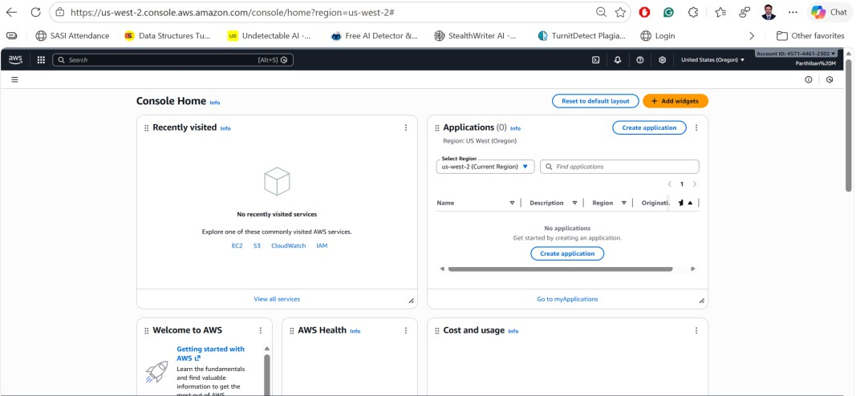

Step 2: Open EC2 Service
- In the search bar, type EC2
- Click EC2
- You are now in the EC2 dashboard

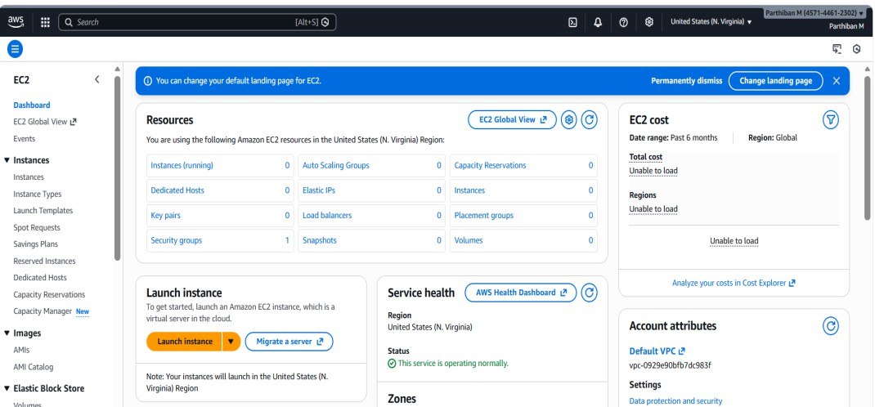

Step 3: Launch a Virtual Machine (Instance)
- Click Launch Instance
- Enter Name: parthimitit

Step 4: Choose Operating System
- Select Amazon Linux 2
  - This is a free Linux OS provided by AWS

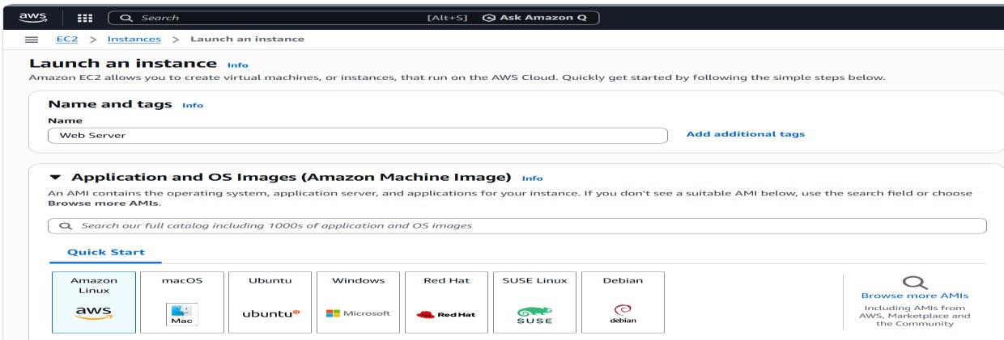

Step 5: Choose Instance Type
- Select t2.micro
  - Free Tier
- Click Next

Step 6: Create a Key Pair (Login Password)
- Click Create new key pair
- Name: mykey
- Type: RSA
- Download .pem file

Do not delete this file

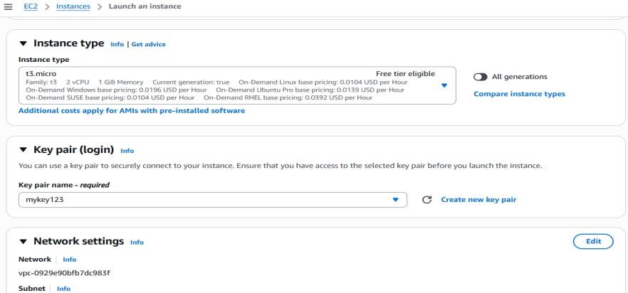

Step 7: Create Security Group (Firewall)
A Security Group controls which traffic is allowed.
- Select Create new security group
- Add rules:
Purpose | Port | Source
SSH (Login) | 22 | My IP
HTTP (Website) | 80 | Anywhere
This allows:
  - You to login (SSH)
  - Everyone to see the website

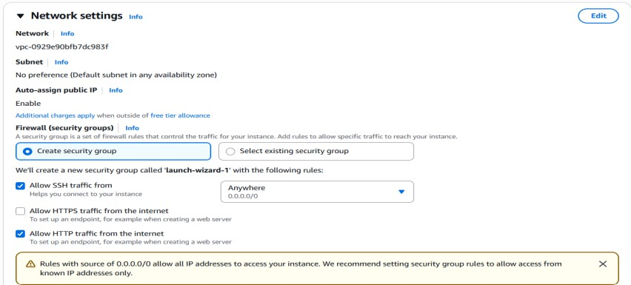


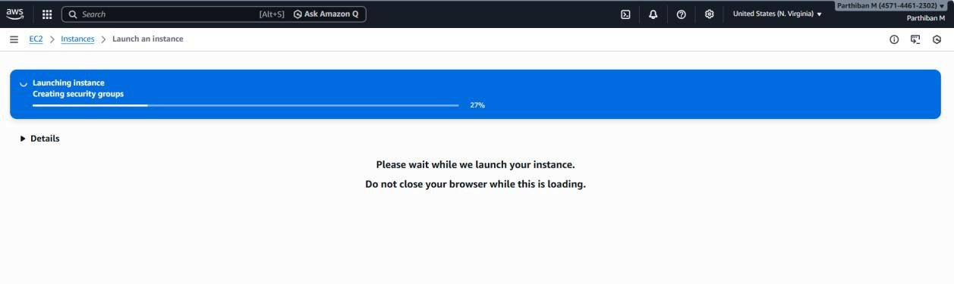

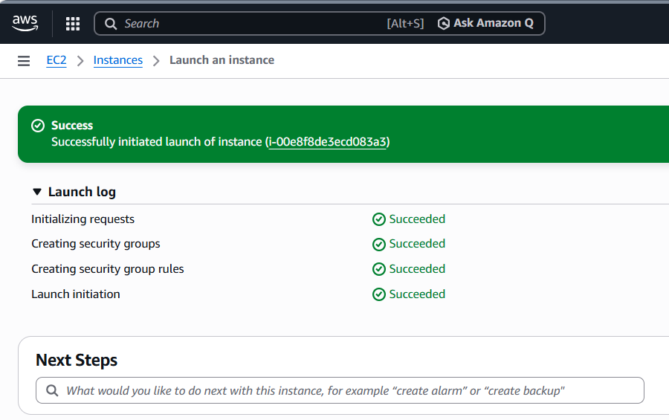
Step 8: Launch the Instance
- Click Launch Instance
- Wait until status shows Running

Step 9: Get Public IP Address
- Click your instance
- Copy Public IPv4 address
This IP is used to access your website.


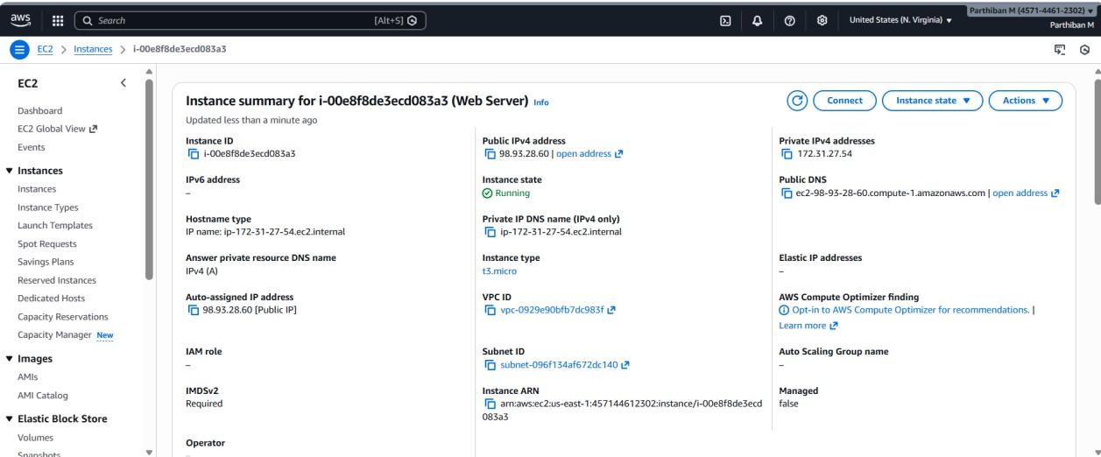

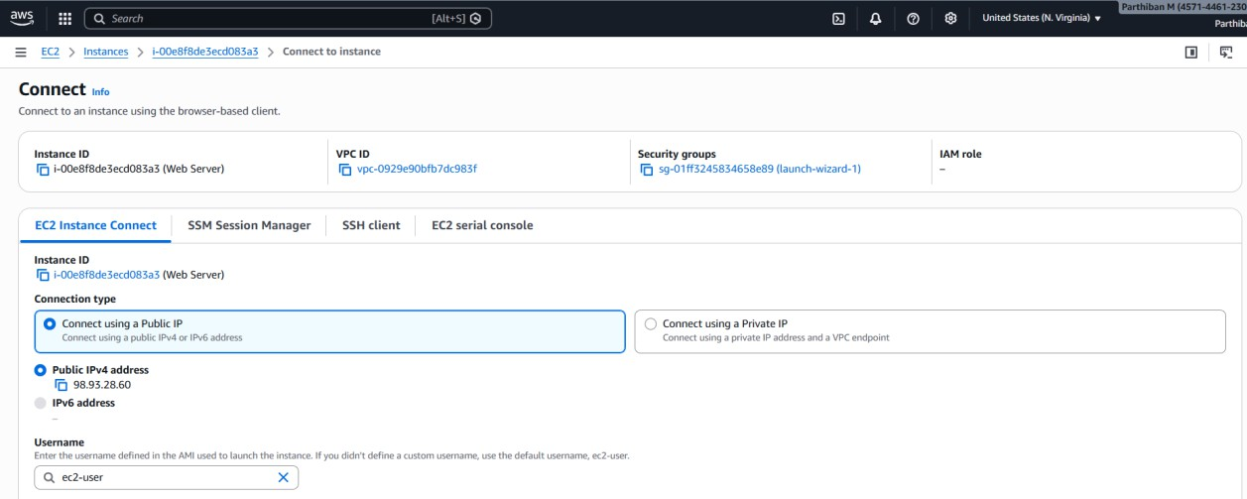

Step 10: Connect to the Instance
- Click Connect
- Choose EC2 Instance Connect
- Click Connect
Now you are inside the cloud computer


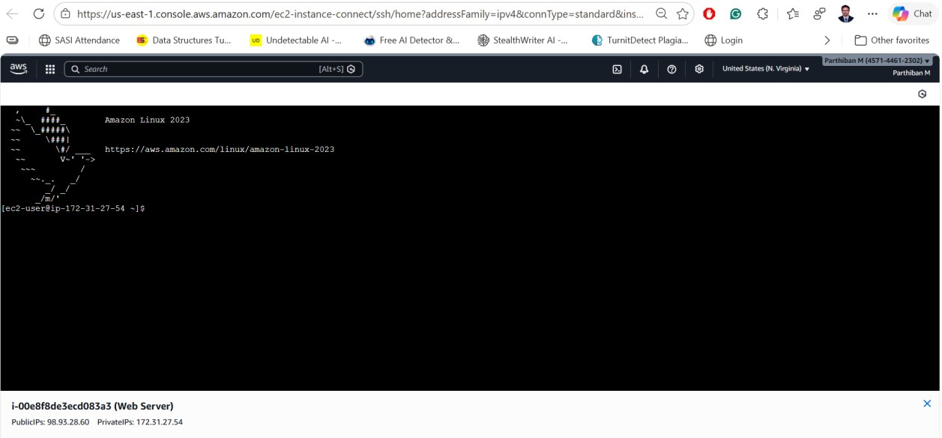

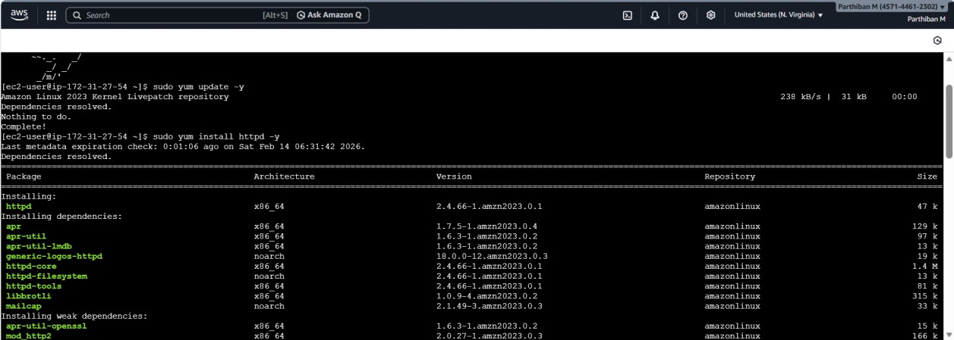

Step 11: Install Web Server
Type these commands one by one:
sudo yum update -y sudo yum install httpd -y
sudo systemctl start httpd sudo systemctl enable httpd

  - This installs Apache web server
  - Starts it
  - Enables it permanently

Step 12: Create a Website
cd /var/www/html sudo nano index.html


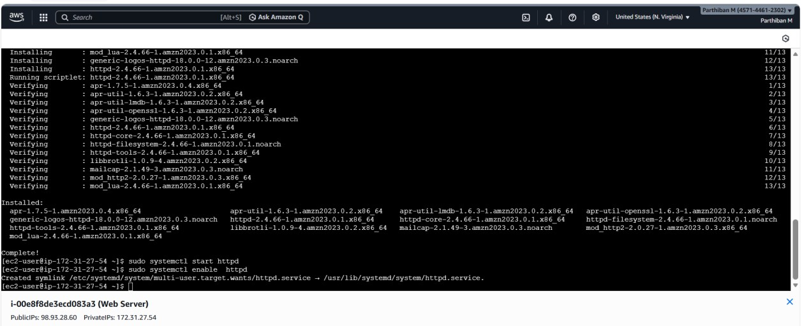

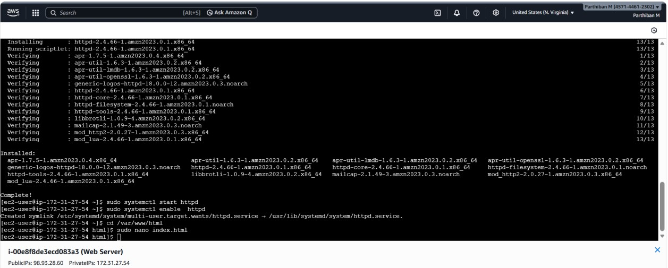
Type:

Save and exit.

<h1>Hello World from EC2</h1>


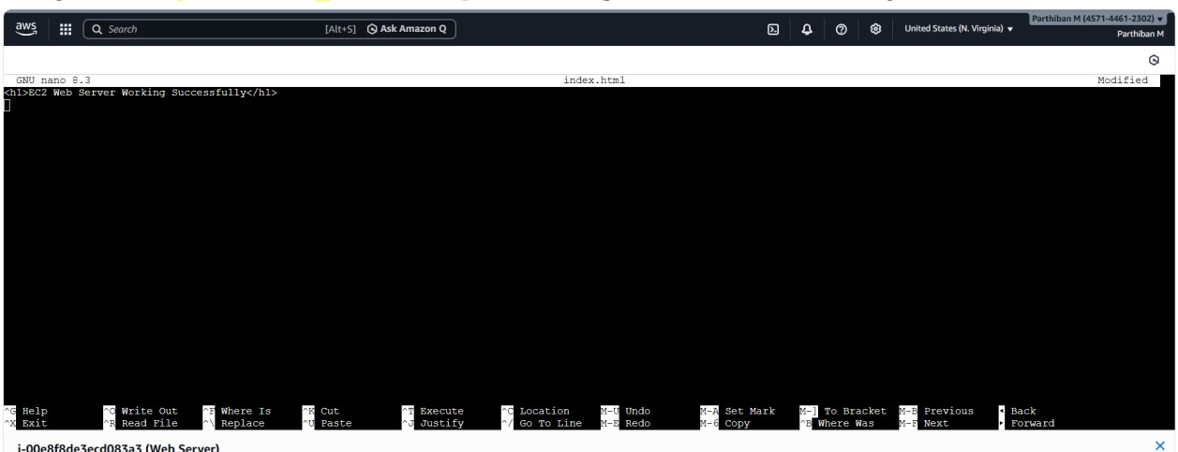

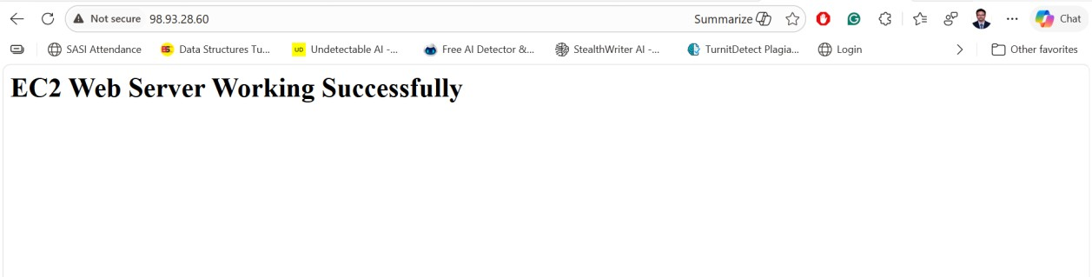

Step 13: Open Website
- Open browser
- Enter:
http://<Public-IP> You will see your webpage

How to Stop an EC2 Instance Safely
- Go to EC2 → Instances
- Select the instance (tick the checkbox)
- Click Instance state (top right)
- Click Stop instance
- Click Stop to confirm
Wait until Instance state = Stopped


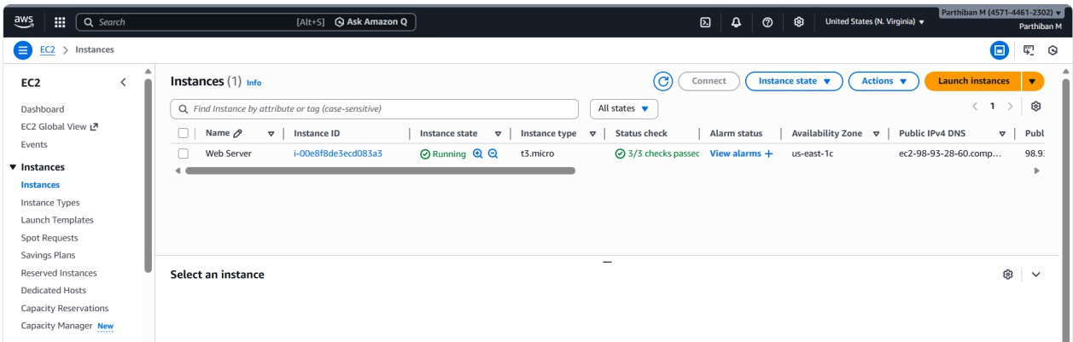

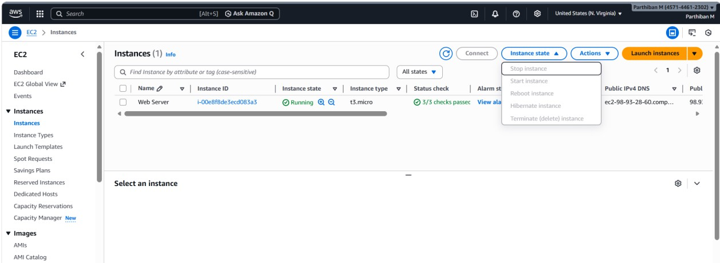

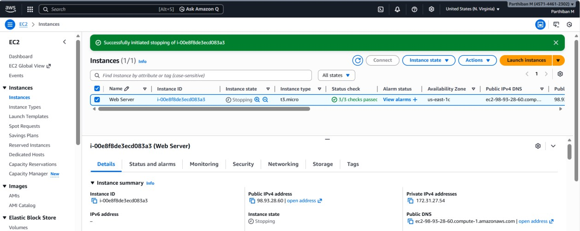

TROUBLESHOOTING / IMPORTANT NOTES (ELABORATED)
- Ensure the EC2 instance state is Running before connecting or accessing the website.
- Select t2.micro instance type to avoid free-tier and launch issues.
- Verify the correct region is selected while launching and accessing the instance.
- Check that the security group inbound rules allow:
  - SSH on port 22 from My IP
  - HTTP on port 80 from Anywhere (0.0.0.0/0)
- Confirm that the Public IPv4 address is used in the browser, not the private IP.
- If unable to connect to the instance, ensure the correct key pair (.pem file) is used.
- Restart the web server if the webpage does not load:
sudo systemctl restart httpd
- Check Apache service status and ensure it is running:
sudo systemctl status httpd
- Verify that index.html is created inside /var/www/html directory.
- Use sudo while editing or creating web files to avoid permission denied errors.
- Ensure Apache is installed properly using:
sudo yum install httpd -y
- If public IP changes after stopping the instance, allocate and associate an Elastic IP.
- Refresh the browser or clear cache after making changes to the web page.
- Reboot the instance if services do not respond properly.
- Double-check all commands for typing errors.

VIVA QUESTIONS AND ANSWERS

Q1. What is cloud computing?
Cloud computing is the delivery of computing resources like servers, storage, and software over the internet on demand.

Q2. What is AWS?
Amazon Web Services (AWS) is a cloud service platform that provides computing, storage, and networking services.

Q3. What is EC2?
EC2 (Elastic Compute Cloud) is an AWS service that provides virtual servers called instances.

Q4. What is an EC2 instance?
An EC2 instance is a virtual machine running in the AWS cloud.

Q5. What operating system is used in this experiment?
Amazon Linux 2 is used.

Q6. What is a web server?
A web server is software that delivers web pages to users through a browser.

Q7. Which web server is used in this experiment?
Apache HTTP Server (httpd) is used.

Q8. What is a security group?
A security group is a virtual firewall that controls inbound and outbound traffic for an EC2 instance.

Q9. Why is port 80 opened?
Port 80 is opened to allow HTTP traffic for accessing the website.

Q10. Why is port 22 used?
Port 22 is used for SSH to securely connect to the EC2 instance.

Q11. What is a key pair?
A key pair is used for secure authentication while connecting to an EC2 instance.

Q12. What is a public IP address?
A public IP address allows access to the EC2 instance from the internet.

Q13. What is an Elastic IP?
An Elastic IP is a static public IP address provided by AWS.

Q14. Why do we use Elastic IP?

To avoid IP address changes when the instance is stopped and started.

Q15. What is the default directory for web pages in Apache?
/var/www/html

Q16. What happens if HTTP rule is not added to the security group?
The website will not be accessible from the browser. Q17. What instance type is used and why? t2.micro is used because it is free-tier eligible.

Q18. What command is used to start Apache?
sudo systemctl start httpd

Q19. How do you check whether the web server is running?
By using the command sudo systemctl status httpd.

Q20. What is the outcome of this experiment?
A web server is successfully hosted on an EC2 instance and accessed using a public IP address.

RESULT
An EC2 instance was successfully created, a web server was installed, port 80 was enabled using a security group, and the website was accessed using the public IP address.

